**Branch**

A branch represents an independent line of development. The git branch command lets you create, list, rename, and delete branches. It does not let you switch between branches or put a forked history back together again. For this reason, git branch is tightly integrated with the git checkout and git merge commands.

Method 1: Creating a branch On GitHub, navigate to the main page of the repository. Click the branch selector menu. Type a unique name for your new branch, then select Create branch.

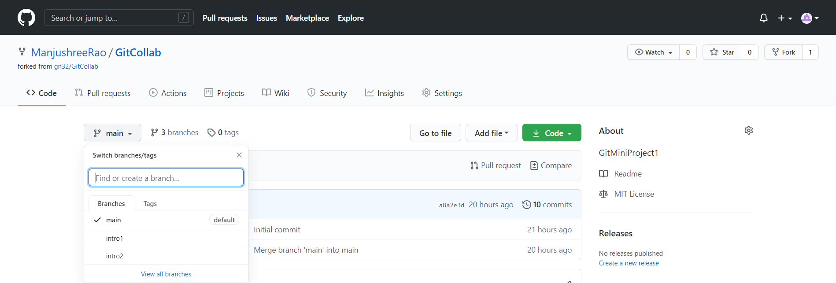

Method 2: You can do this with

***$ git branch <branch name>***

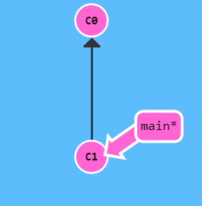 **🡪** 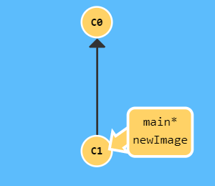*Note: newImage is the new branch created*

Method 3: To create the branch from your current branch and it will switch you to that branch in a single command.

You can do this with

***$ git checkout -b <branch-name>***





